OFFICIAL LEAGUE ROSTER - BASKETBALL
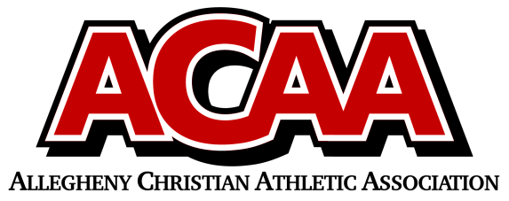

School Name: Great Commission School
Team Colors: Royal Blue & White
Overall Wins ___ Losses ____ Ties ___
ACAA Wins ___ Losses ____ Ties ___ OPPONENT: __________________________
DATE: _________
Number | Name | Year | Position | Height | Homeschool
1 | Elijah Best | 12 | G | 5’9
3 | Alex Guise | 12 | F | 6’1
2 | Camden Hileman | 12 | F | 5’11
34 | Marco Palazzi | 12 | F | 6’2
20 | Noah Lawson | 12 | G | 5’9
10 | Ian Grissinger | 11 | G | 5’7
21 | Zach Best | 10 | F | 5’10
11 | Donovan Bickings | 10 | C | 6’1
35 | Landyn Ulrich | 10 | C | 6’1
0 | Joel Lohsl | 9 | G | 5’8
4 | Kavion Rodgers | 9 | C | 6’1

Head Coach: AARON BENSON
Asst. coach: ZETH OSBORN

AD: JULIE LOHSL

Official ACAA League Team Roster. to be submitted to the scorer’s table before each game.

